**WAWA (Liberia) Visitors’ Welcome Pack**

|  |  |
| --- | --- |
| **Scope** | **Regional People Management Framework** |
| **Introduction** | The nature of WaterAid’s work necessitates working in volatile and sometimes violent environments. At times this presents a threat to the security and well-being of our staff; an issue the organisation takes very seriously.  A Country Welcome Pack provides staff and visitors with a broad overview of the environment in which they are working or travelling to including essential security information good to know prior to visiting. It describes other factors that may not be included in a security plan such as currency information, cultural norms, local considerations, sensitivities, etc. |
| **Purpose** | The aim of this document is to inform short-term visitors of useful information that is important for their visit. Your welcome pack should:   * Provide a brief summary of the country including safety and security * Provide information on cultural practices * Provide information regarding airports and accommodation * Provide useful hints and tips regarding dress, communications, electricity, currency, eating out, getting around, health and climate. * Contain a short declaration to be signed by the visitor after the In-Country security briefing, whereby acknowledging that s/he is informed and understand the risks (informed consent). * To satisfy one of the requirements of WA’s duty of care.   Preferably visitors should be able to access this – or receive by mail – prior to departing for your country as a Pre-Departure brief. |
| **First Published** | **2017** |
| **First Revision** | **2018** |

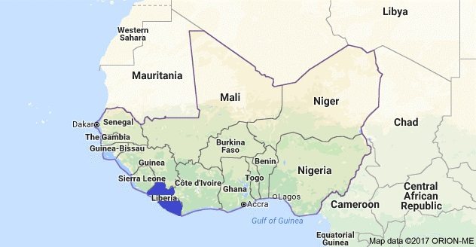

**CHAPTER 1: Global Security Framework**

**1.1 Global Security Framework**

* + 1. This document is part of the Global Security Framework that consists of policies, a toolkit, procedures and a template pack, as illustrated below.

Policies

Toolkit

Procedures

Templates

Global Security Policy

Emergency Number

Crisis Management

Medical Response & Evacuation

Repatriation of Deceased

Psychosocial Care

Incident Reporting

Kidnap

Security Handbook

Essential Security Package

Security Plan

Welcome Pack

‘RED’ Form

Contingency Plans

Risk Assessment

Context Analysis

Incident Report Form

International & Domestic Travel

Liberian Flag

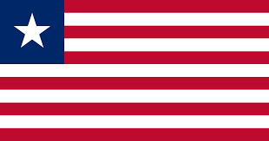

Monrovia, Liberia

[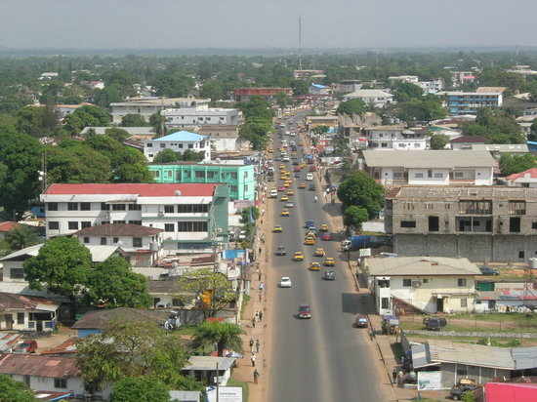](https://www.tripadvisor.com/LocationPhotoDirectLink-g293805-i18870848-Monrovia_Montserrado_County.html)

**CHAPTER 2: INTRODUCTION**

2.1.1 WaterAid Liberia is often hosting international visitors from member offices, donors and supporters.

The aim of this Welcome Pack is to inform short-term visitors of useful information that is important for their visit. It is updated regularly to reflect current security situation in Liberia, and will also provide some useful information that visitors should know before starting their journey.

The document serves as a Pre-Departure Brief and will be supplemented by a verbal security briefing upon arrival to Liberia.

**CHAPTER 3: SECURITY WELCOME PACK**

**3.1 Country Summary**

*3.1.1* Africa's first republic, Liberia was founded in 1822 as a result of the efforts of the American Colonization Society to settle freed American slaves in West Africa. The society contended that the emigration of blacks to Africa was an answer to the problem of slavery and the incompatibility of the races. Originally called Monrovia, the colony became the Free and Independent Republic of Liberia in 1847. Lying on the Atlantic in the southern part of West Africa, Liberia is bordered by Sierra Leone, Guinea, and Côte d'Ivoire. It is comparable in size to Tennessee. Most of the country is a plateau covered by dense tropical forests, which thrive under an annual rainfall of about 160 in. a year.

|  |  |
| --- | --- |
|  | *Liberia* |
| *Capital* | *Monrovia* |
| *Land area* | *111 000 km2* |
| *Independence* | *26 July 1847* |
| *Life expectancy* | *56.8 years* |
| *GDP per capita (PPP)* | *USD 552* |
| *Annual Growth* | *4.6%* |
| *Currency* | *Liberian dollar (LRD)* |
| *Human Development Index*  *Access to Water*  *Access to Sanitation* | *Rank 182 (out of 187 countries)*  ***60%***  ***34%*** |

*3.1.2* **Political system: Republic, multiparty system**

*3.1.3* **Health and Safety**

Malaria is prevalent in Liberia and is a serious health risk. To avoid being affected, kindly follow all the known preventive measures required. In case you feel symptoms of malaria or any other disease, kindly contact a member of staff (preferably the Country Director or the Deputy Country Director) who will support you acquire the needed medical attention.

You are advised to take your International Travel Vaccination against Yellow Fever. Please ensure you update your travel medical insurance and your WHO’s International Certificate of Vaccination – Yellow Card.

**The following clinics are our preferred medical service providers:**

|  |
| --- |
| 1. SOS Clinic, Congo Town Monrovia |
| 1. St Joseph Catholic Hospital, Monrovia |
| 1. ELWA Hospital, RIA High way |
|  |

**3.2 Entry Requirements**

*3.2.1 Clarify details for entering into Liberia including Visa requirement/ types and any health certificate requirements (e.g. Yellow Fever Certificate). Explain procedures at arrival to the airport, e.g. immigration procedures or other specific procedures visitors should be prepared for e.g. procedures related to recent Ebola virus outbreak in West African countries.*

*3.2.2 Clarify what visitors can legally bring into the country, e.g. alcohol, tobacco, perfume, cosmetics bought Duty Free, and make clear what restrictions or prohibitions are, e.g. illegal drugs, pornographic material etc.*

*3.2.3* ***Getting there:***

*Upon arrival in Liberia,* ***WaterAid Liberia driver (Jayah Fofana)*** *will receive you at the airport and take you to the hotel already booked for you.*  Please talk with the driver who will be with you for information on good restaurants to eat.

**3.3 Safety & Security:**

Monrovia, the capital city is quiet. However, for your safety, you are advised to keep your jewels and handbags tight when out of a secured environment. You may use the hotel safe to keep your valuables (see hotel reception). Please see the attached risk assessment.

Monrovia, the capital city of Liberia is quiet but with minimal criminal activity like pick pockets. However, for your safety, Ensure when going out to town/crowded area/ the beach area you handle your cash well for pickpockets.

For all other logistics (phone card, transport, per diem) our HRAO Sheku Daboh will be in charge, he can be reached on **(+231770135478)** and (**+231886542752)**

Upon arrival, you will receive a full verbal security briefing upon arrival to our office, delivered by the SFP:

Name: Sheku Daboh

Mobile No.: +231770135478

Mail: [shekudaboh@wateraid.org](mailto:shekudaboh@wateraid.org)

**3.4.1 Nice to Know**

A WaterAid staff will support you carry out any financial transaction during your stay in Liberia. The current exchange rate of the local currency-the Liberia dollar to other currency is as follows:

$1.00 = LRD 150.00

However, these exchanges rates fluctuate very often.

**3.4.2 Telephone:** WaterAid Liberia will provide you with a mobile SIM card and call credits to communicate whilst in Liberia **(When Applicable)**

**3.4.3 Airline booking & tickets confirmation**

Please note that reconfirmation should be done immediately upon arrival and that an OK and/or reconfirmation obtained outside of Liberia should be confirmed as valid. **Sheku Daboh** would provide support to reconfirm your tickets.

* + 1. **Accommodation**

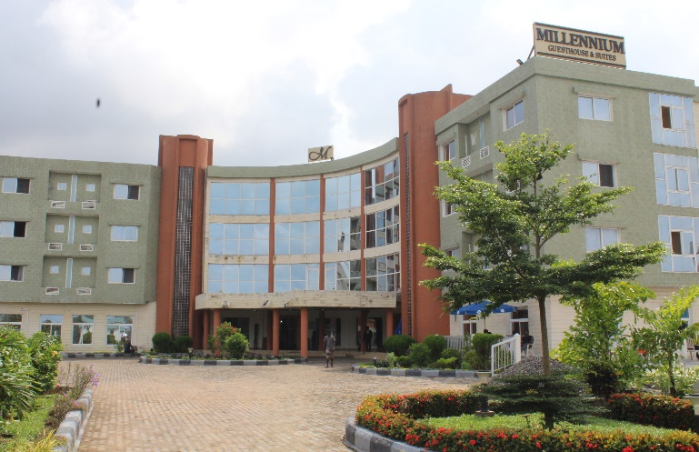In Liberia, you will be accommodated in the **Millennium Guest House & Suites** in Congo Town, off Tubman Blvd, the main road in the City and about a kilometer away from our offices. <https://www.mghs.afriklandhotels.com/>



**3.5.2 Clothing**

Being that the raining weather is anticipated to remain with us during the time of your stay, nonetheless it is advisable to bring along light wears that are appropriate for tropical terrains, but long sleeves shirts are recommended to protect you against mosquitoes. Temperatures are expected to average a low of 24 and high of 27 Degree Celsius during your stay.

**3.5.3 Religion**

Christianity and Islam are the main religious sects in Liberia with the first being the dominant. Unlike other countries, Liberia is highly esteemed for religious tolerance.

**3.5.2 Photographing**

Please use caution or seek permission before taking photographs, especially government buildings, or security spots as this may lead to being questioned by security or your camera being confiscated

**3.5.3 Sightseeing and Gifts**

Gift could be purchased at the supermarkets along Tubman Boulevard in Monrovia. The general markets in central Monrovia can be a good place to purchase gifts made in Liberia

**3.5.4 Recommended Restaurants**

In addition to the **Millennium Guest House & Suites**, the below restaurants are recommended for meals. Restaurants in Monrovia are opened between 12 noon and 9 pm.

* Level 1 Restaurant, 9th street, Monrovia
* Fuzion Restaurant, 15th Street Monrovia
* RLJ Restaurant, Paynesville
* Grand Royal Hotel
* Boulevard Palace
  1. **Key Contacts**

WaterAid Liberia

Opp. German Embassy, Congo Town. Liberia

Country code for Liberia is +231776250870

|  |  |  |  |
| --- | --- | --- | --- |
| WaterAid Liberia  Opp. German Embassy, Congo Town. Liberia  Country code for Liberia is +231 | | | |
| Name | Designation | Phone | Email |
| Patrick N. Cheah | Country Director | +231777235390 | [patrickcheah@wateraid.org](mailto:patrickcheah@wateraid.org) |
| Chuchu K. Selma | Deputy Country Director | +231776755740 | [chuchuselma@wateraid.org](mailto:chuchuselma@wateraid.org) |
| Sheku A. Daboh | HR/Administration Officer | +231770135478 | [shekudaboh@wateraid.org](mailto:shekudaboh@wateraid.org) |
| Police | National HQ | 911 |  |

